SCRABBLE PROGRAM 9000

USER MANUAL

WRITERS:

MEMBERS OF CSE-t47

OF CSE116

UNDER DR. ALPHONCE

**TABLE OF CONTENTS**

INTRODUCTION

1. BEGINNING THE GAME . . . . . 4

1.1 SETTING NUMBER OF PLAYERS

1.2 SETTING PLAYERS’ NAME

2. HOW TO PLAY THE GAME . . . . 5

2.1 PLACEING A TILE

2.2 PASSING A TURN

3. HOW TO SAVE AND LOAD THE GAME . . . . . 6

3.1 SAVING THE GAME

3.2 LOADING THE GAME

INTRODUCTION

Scrabble is a word game, which players get points by placing tiles of characters onto a game board that is divided in rectangular shapes of 20 by 20 and forming a word out of those tiles.

When you start a game, each player gets some tiles out of 56 tiles in an inventory. Some tiles have more point value. A distribution and point value of tiles are explained in the table below.

|  |  |  |
| --- | --- | --- |
| LETTERS | NUMBER OF TILES FOR EACH LETTER | POINT VALUE FOR EACH LETTER |
| A,E,I,O,U | 29 | 1 |
| Y | 15 | 2 |
| B,C,D,F,G,H,J,K,L,M,N,P,Q,R,S,T,V,W,X,Y,Z | 12 | 5 |

Players alternate each turn. A player can use every tile on his tile rack. The tile rack will be refilled after each turn from the inventory. When the inventory becomes empty, the tile rack doesn’t get refilled.

The player can get points when he assembles an English word by placing tiles on squares in a vertical or horizontal position.

The player with the greatest score at the end of the game wins.

BEGINNING THE GAME

Setting the number of players

When you start the SCRABBLE PROGRAM 9000, your computer prompt will show something like below:

/Users/jasonkimik/Desktop/Screen Shot 2015-04-09 at 9.35.19 PM.png

When you see this prompt, you need to enter number of people who are going to play the game. Remember that only four people can play the game at the same time.

Setting player’s name

After entering in the number of players, you will see something like below:

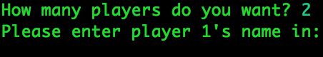

When you see this prompt, you need to enter each player’s name.

HOW TO PLAY THE GAME

SCRABBLE PROGRAM 9000 uses an innovative UI by using a tool called a mouse. You control a pointer on your screen by moving the mouse. You can choose an element by clicking a button that resides on the mouse.

Please be reminded that the UI shown at examples may look different from yours.

PLACING A TILE

When you start the game, you will see several windows: a main window, players’ tile racks, and an option window.

Before placing a tile, you may need to check whether it is your turn or not.

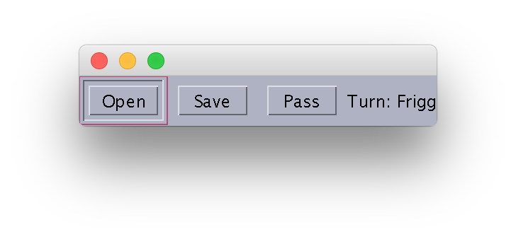

You can check the turn by referencing the option window

In order to place a tile, you need to click a tile you want to place on your tile rack.

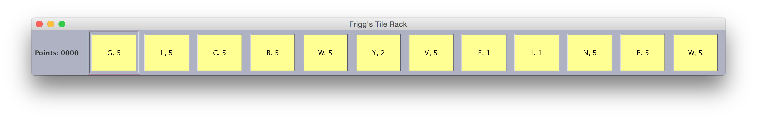

The points label on the left shows how much points you have right now.

After clicking the tile, you need to click a blank rectangular shape. The program will place the tile you choose on the main window.

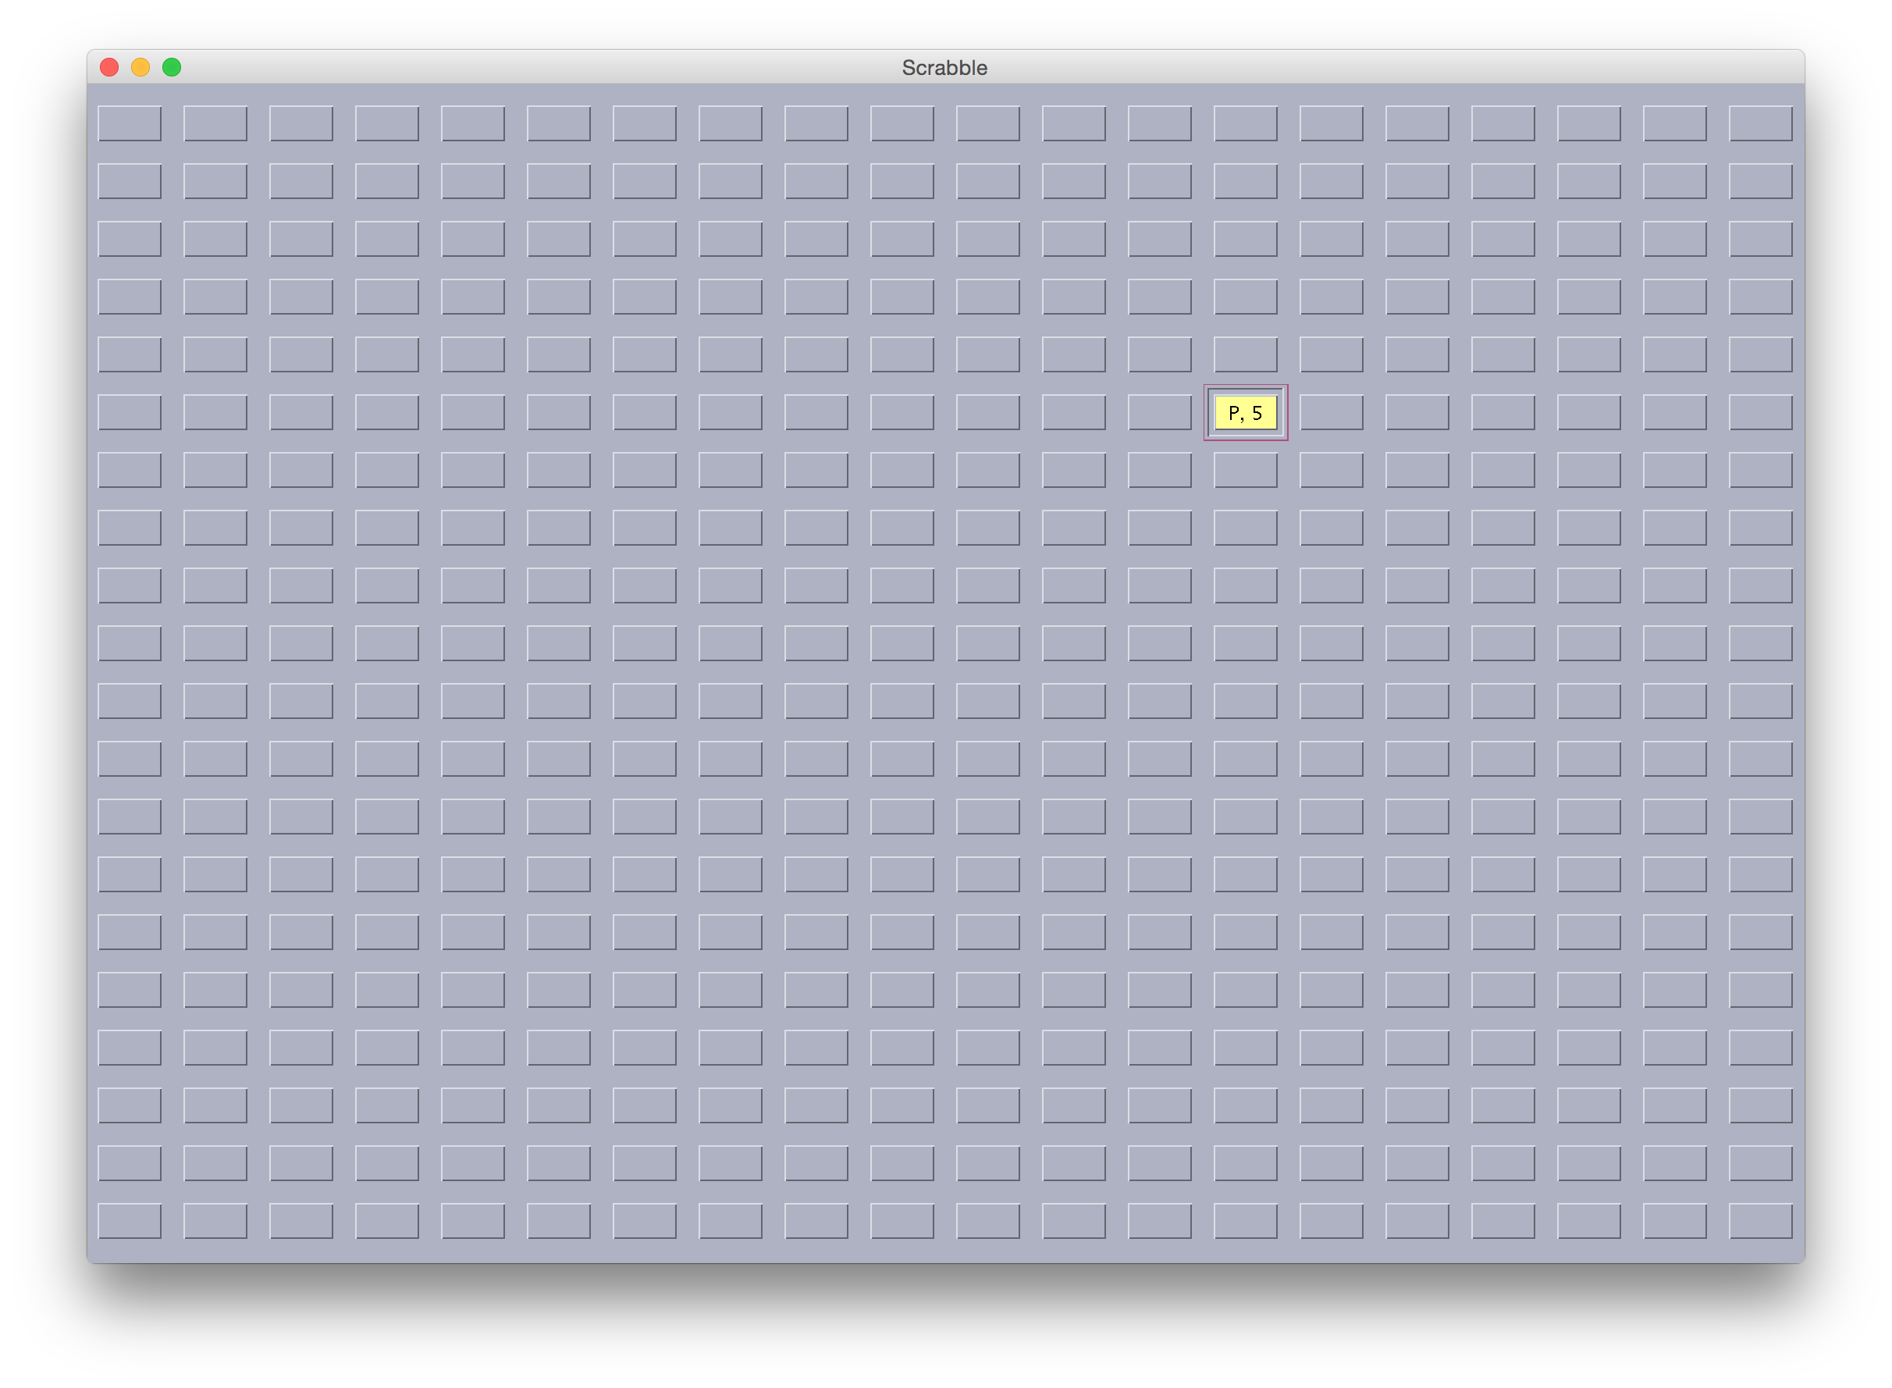

PASSING A TURN

After finishing placing the tiles, you need to pass a turn to another player. Clicking the PASS button on the option window will easily do the job.



When you pass your turn, a pop-up message will show up to remind you that you have passed your turn.

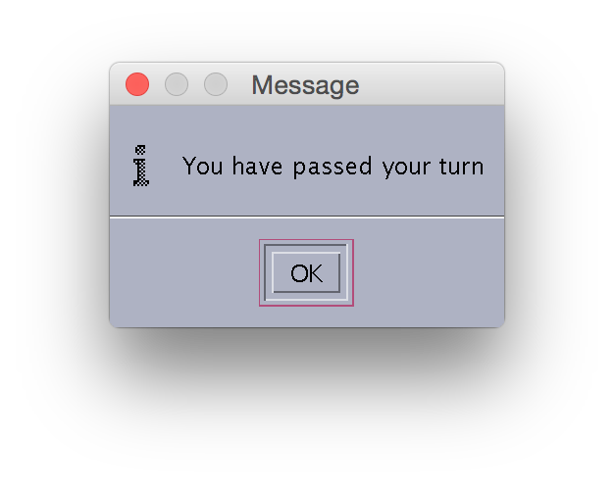

HOW TO SAVE AND LOAD THE GAME

SAVING THE GAME

Saving the game can be easily done by clicking the Save button on the option window.



Clicking the Save button will show a window like below:

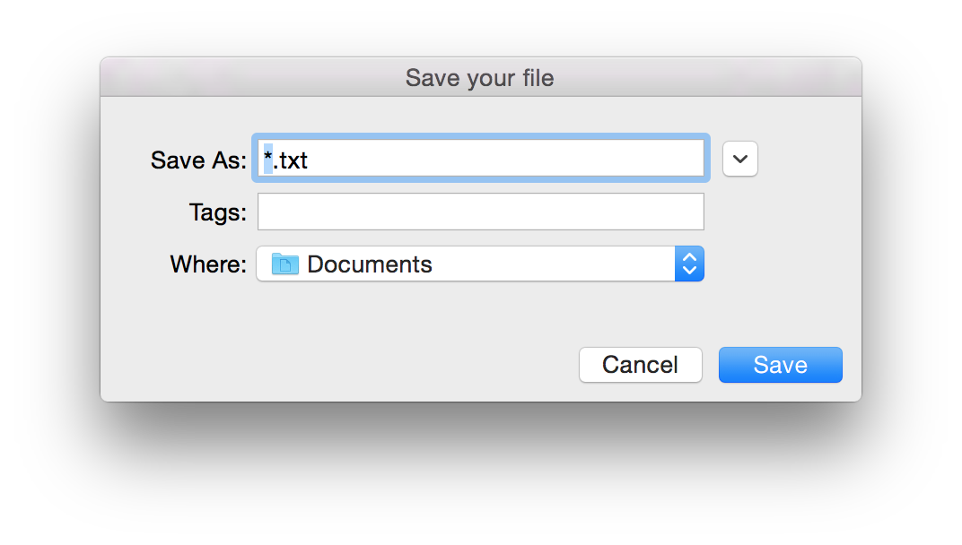

After choosing the file name and where to save the file, please click the save button.

LOADING THE GAME

When you click the Open button, a window that resembles what you saw when you saved. You should choose a save file to load and choose the Open button on the window that popped up.